50% reduction in fees for pupils in receipt of TARGETED Free School Meals for one shared lesson per week, on one instrument
100% reduction in fees for Children in Care for one shared lesson per week, on one instrument
100% reduction on Kickstarters Programme students on their first year of learning
Calculations will be deducted in each term, but the form only needs to be sent in once for the year.
APPLICATIONS CAN ONLY BE MADE PER TERM
Email the completed form to music.service@norfolk.gov.uk
If demand exceeds budget, eligible applications will be awarded on a first come first served basis
To be completed by parent or carer:
Norfolk Music Service operates the following remission policy for pupils in receipt of Norfolk Music Service Instrumental Tuition or membership of a Norfolk Music Service led ensemble:
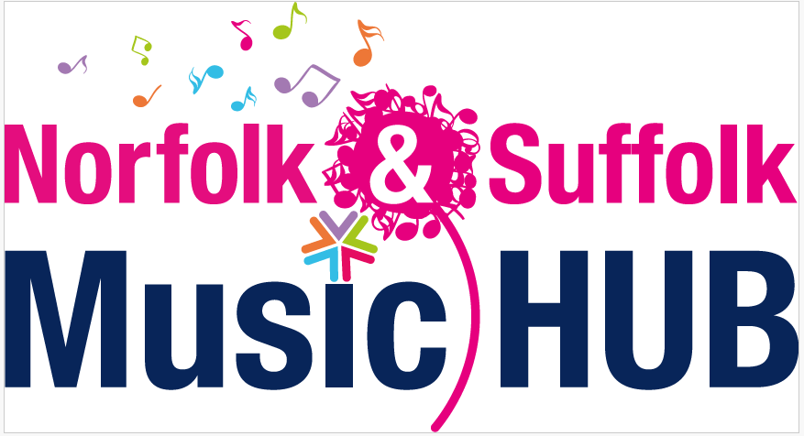

Name of School
Email of School Office
Name of Parent/Carer
Email address of Parent /Carer
Date the form is completed

Pupil First Name | Surname | Year Group | Age | Remission Group; FSM, Kickstarter or CIC | No of weeks claimed for | Ensemble Group

